Sales Data Sample Report
Introduction
This report analyzes a detailed sales dataset, focusing on ORDERNUMBER, QUANTITYORDERED, PRICEEACH, and SALES attributes. It aims to provide insights to guide sales strategies and enhance business performance, targeting sales managers, marketers, and executives. Key analyses include comparing Vintage cars and Classic cars sales, determining average sales, identifying top-selling products, assessing profit by country for specific product lines, comparing sales across years, and evaluating countries by deal size. The project's scope encompasses extracting insights to optimize sales strategies, product offerings, and overall business performance, catering to analysts and researchers interested in sales dynamics and market trends.
Questionnaire
1. Comparison of sales between Vintage cars and Classic cars across all countries.
2. Determination of the average sales of all products and identification of the highest-selling product.
3. Assessment of the country yielding the most profit for Motorcycles, Trucks, and Buses.
4. Comparison of sales for all items across the years 2004 and 2005.
5. Comparative analysis of all countries based on deal size.
Analytics
Q1. Comparison of sales between Vintage cars and Classic cars across all countries.
ANS: This analysis compares sales of Vintage cars and Classic cars across countries. USA leads with sales of $2,102,394.02, followed by Spain, France, and Australia.
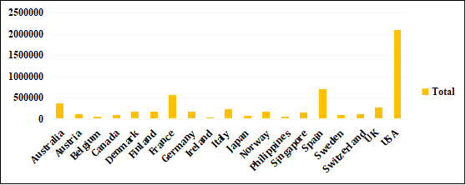
Q2. Determination of the average sales of all products and identification of the highest-selling product.
ANS: This analysis calculates the average sales of all products and identifies the highest-selling product. Classic Cars lead with an average sales of 4,053.377104, followed by Trucks, Buses, and Motorcycles. A graph visually depicts these findings, highlighting Classic Cars as the top-selling product.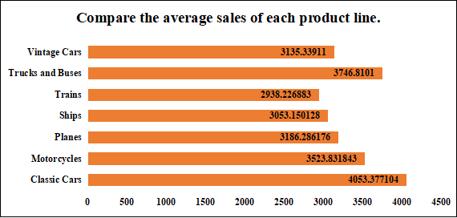
Q3. Assessment of the country yielding the most profit for Motorcycles, Trucks, and Buses.
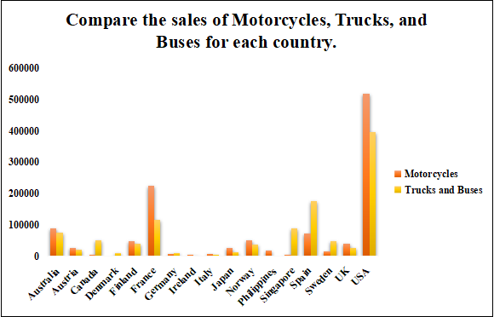
The analysis identifies the top-profitable country for Motorcycles, Trucks, and Buses. The USA leads in sales, followed by France and Spain.
Q4. Comparison of sales for all items across the years 2004 and 2005.
ANS: This analysis compares sales across all items in the years 2004 and 2005. The line chart illustrates dynamic shifts in sales over the years, with Classic cars consistently leading in both 2004 and 2005, totaling $1,762,257.09 and $672,573.28, respectively. The chart visually depicts sales fluctuations across categories, highlighting Classic cars' consistent dominance throughout the analyzed period.
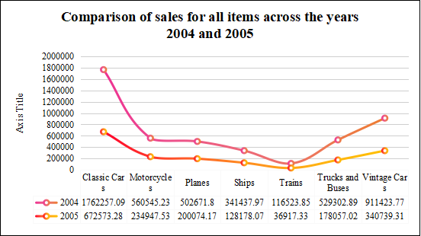
Q5. Comparative analysis of all countries based on deal size.
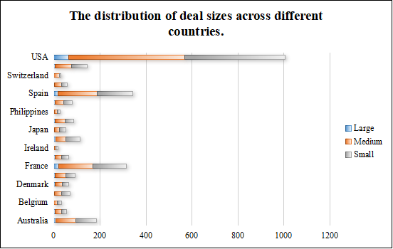
ANS: The analysis investigates deal size distribution across countries. The bar chart reveals the USA's dominance, with significantly larger deal sizes compared to other countries: 64 large, 505 medium, and 435 small deals.
Conclusion and Review
The analysis delves deep into sales dynamics and profitability across categories and countries, revealing the USA as a prominent market leader. Strong sales performance in Vintage and Classic cars, Trucks, Buses, and Motorcycles underscores its dominance. Classic Cars emerge as the top-selling product, driving substantial revenue. The USA showcases exceptional profitability, especially in Trucks, Buses, and Motorcycles. Sales for Classic cars remain robust over the years 2004 and 2005, indicating sustained demand. Moreover, the USA exhibits significantly larger deal sizes, highlighting its sales volume dominance. While the report effectively visualizes key findings, exploring factors influencing sales fluctuations and deal size disparities could provide deeper insights. Overall, the analysis offers valuable insights for refining sales strategies and fostering business growth.
Regression
SUMMARY OUTPUT
Regression Statistics
Multiple R | 0.877178
R Square | 0.769441
Adjusted R Square | 0.766629
Standard Error | 896.6688
Observations | 250
ANOVA
 | df | SS | MS | F | Significance F
Regression | 3 | 6.6E+08 | 2.2E+08 | 273.6567 | 4.62E-78
Residual | 246 | 1.98E+08 | 804014.9
Total | 249 | 8.58E+08
 | Coefficients | Standard Error | t Stat | P-value | Lower 95% | Upper 95% | Lower 95.0% | Upper 95.0%
Intercept | -5271.93 | 322.9166 | -16.326 | 4.32E-41 | -5907.96 | -4635.9 | -5907.96 | -4635.9
X Variable 1 | 103.0809 | 6.001152 | 17.17685 | 5.42E-44 | 91.26071 | 114.9011 | 91.26071 | 114.9011
X Variable 2 | 12.81807 | 1.661734 | 7.713668 | 3.04E-13 | 9.545024 | 16.09111 | 9.545024 | 16.09111
X Variable 3 | 47.42944 | 3.350938 | 14.15408 | 1.13E-33 | 40.82925 | 54.02963 | 40.82925 | 54.02963

Anova (One factor)

Anova: Single Factor
SUMMARY
Groups | Count
Column 1 | 250 | 903280.9 | 3613.123 | 3445221
Column 2 | 250 | 25534 | 102.136 | 1664.552
ANOVA
Source of Variation | SS | df | MS | F | P-value | F crit
Between Groups | 1.54E+09 | 1 | 1.54E+09 | 894.0704 | 3.1E-113 | 3.860199
Within Groups | 8.58E+08 | 498 | 1723443
Total | 2.4E+09 | 499

Anova (Two factor)

Anova: Two-Factor Without Replication
SUMMARY | Count |  | Sum |  | Average |  | Variance
Row 1 | 3 |  | 4097.66 |  | 1365.887 |  | 5069957
Row 2 | 3 |  | 2451.12 |  | 817.04 |  | 1725170
Row 3 | 3 |  | 1566 |  | 522 |  | 648687
Row 4 | 3 |  | 5095.24 |  | 1698.413 |  | 7507173
Row 5 | 3 |  | 5140.39 |  | 1713.463 |  | 7650609
Row 248 |  | 3 |  | 4386.35 |  | 1462.117 |  | 5944534
Row 249 |  | 3 |  | 2261.6 |  | 753.8667 |  | 1546167
Row 250 |  | 3 |  | 4176.72 |  | 1392.24 |  | 5420980
Column 1 |  | 250 |  | 903280.9 |  | 3613.123 |  | 3445221
Column 2 |  | 250 |  | 25534 |  | 102.136 |  | 1664.552
Column 3 |  | 250 |  | 8659 |  | 34.636 |  | 89.69428
ANOVA
Source of Variation |  | SS |  | df |  | MS |  | F |  | P-value | F crit
Rows |  | 2.95E+08 |  | 249 |  | 1182944 |  | 1.044989 |  | 0.33951 | 1.194432
Columns |  | 2.09E+09 |  | 2 |  | 1.05E+09 |  | 925.2361 |  | 1.9E-168 | 3.013826
Error |  | 5.64E+08 |  | 498 |  | 1132016
Total |  | 2.95E+09 |  | 749

Descriptive Statistics
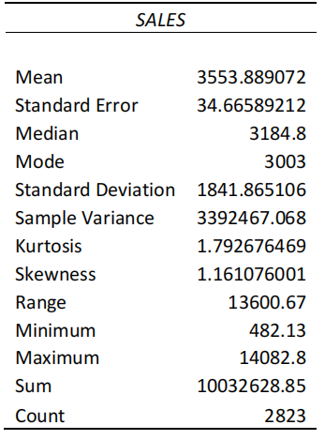

Correlation
 | Column 1 | Column 2 | Column 3
Column 1 | 1
Column 2 | 0.513951 | 1
Column 3 | -0.01254 | 0.663973 | 1

